A

Report

On

WALL MAGAZINE AND QUIZE 2019

Department of PHILOSOPHY

Rabindra Mahavidyalaya, champadanga,hooghly

Session: 2018-19

Theme:Purushartha

Venue: Department of PHILOSOPHY

Rabindra Mahavidyalaya, champadanga,

room no. 71

Date: 29th March ,2019

Organizer: Department of Philosophy

Objectives:

- Development of soft skills.

- Ability to grow presentation skills, engage in meaningful discussion to arrive at a shared understanding their oral work, combining information.
- Enhancing students’ intelligence.

- Building students’ confidence

- Dealing with critical and argumentative situation

summary

A Wall Magazine and Quiz competition is organized by the Department of Philosophy on 29th March 2019. Like in every year, the students of philosophy department have conducted the whole program. The topic of Wall Magazine was” Purushartha”. FirstDr.Piru Pada Malick, Professor of Bengali Department, inaugurated the wall magazine in the presence of professors and students.He delivered an inaugural speech in front of us. He talked about the event and the theme of this wall magazine. Students’ and professors from other departments were also present.
The topic of wall magazine was presented in front of everyone bystudent of philosophy department. Teachers of other departments also gave speeches. Then everyone reaches room no 71 for the rest of the program. Along with some cultural events, such as recitals, dances, songs, speeches etc. are also held.
A quiz competition was organized on that day. Students are divided into ten teams in this competition. Each team hadfour students. The quiz consists of three rounds, in the first round the topic was‘Indianand WesternPhilosophy’, in the second round the topic was ‘Logic’ and in the third roundthe topic was‘General Knowledge’. Students perform very well. The audience enjoyed it very much. They learn a lot.
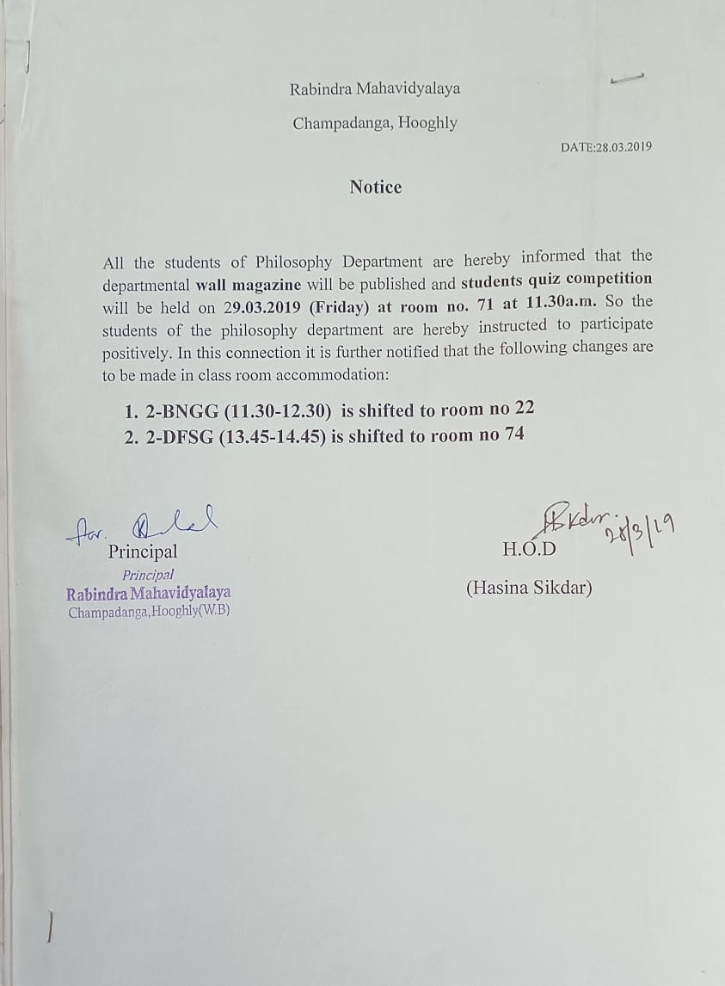
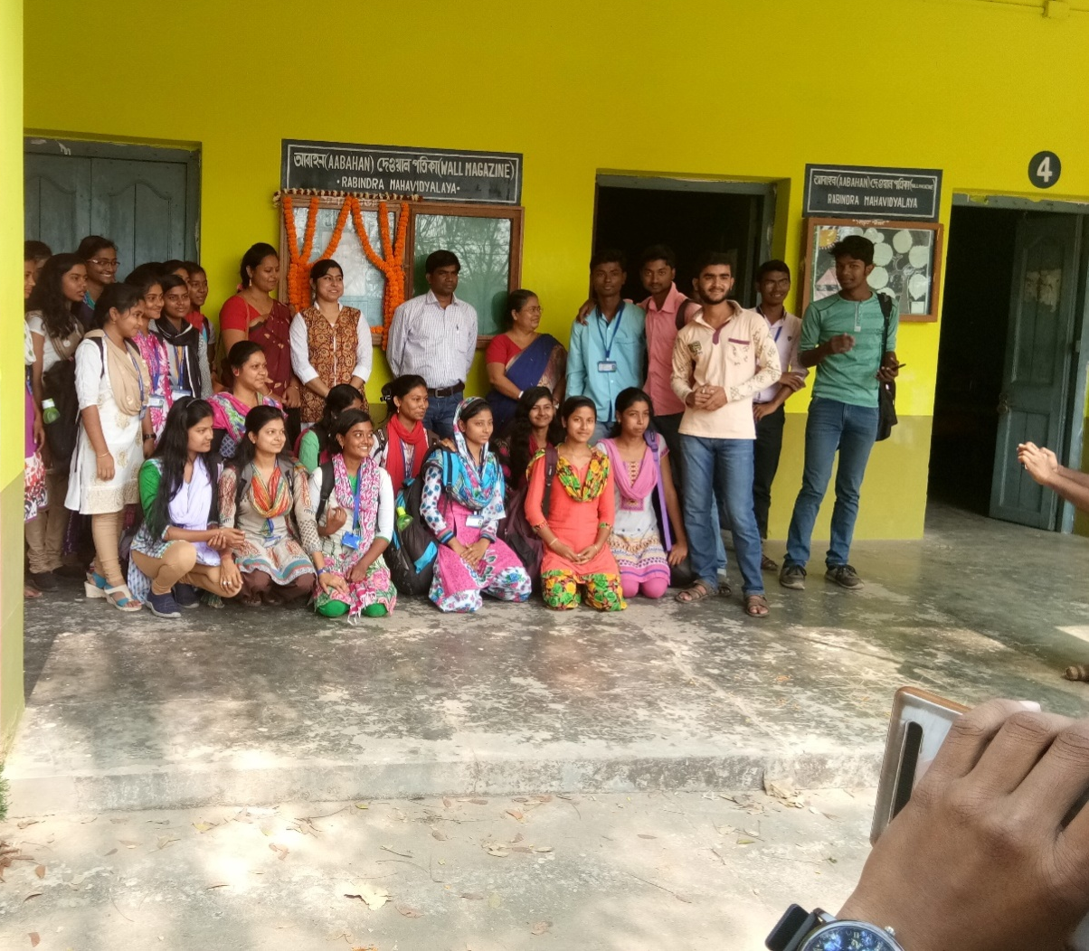
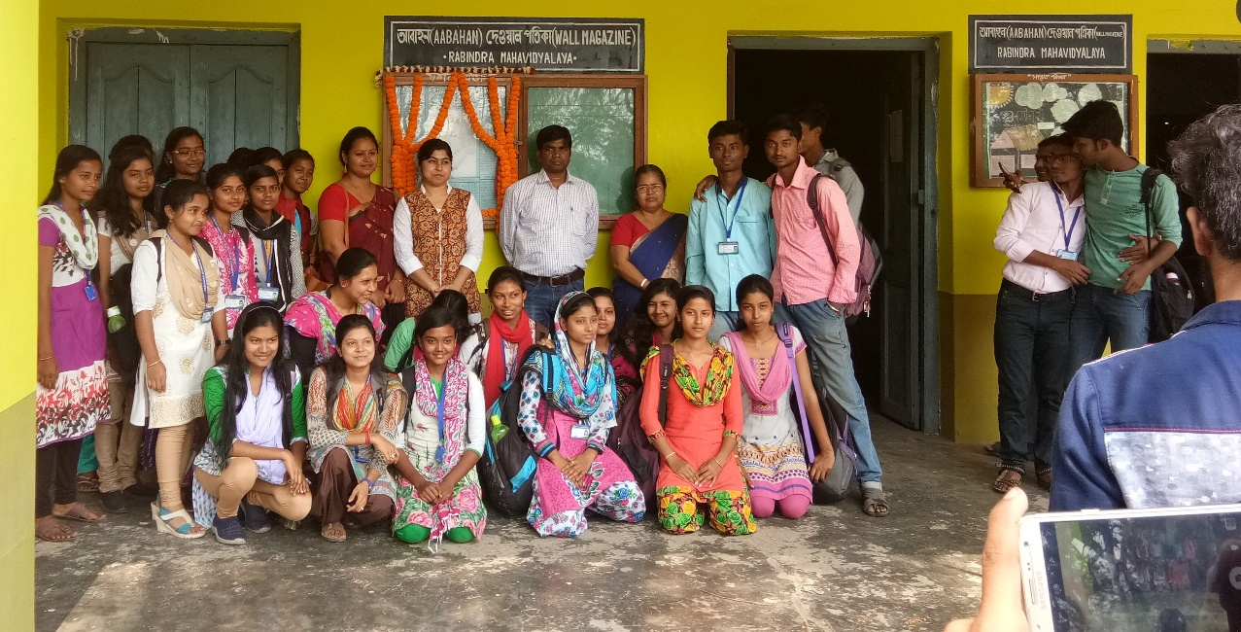
Wall Magazine “Purushartha”
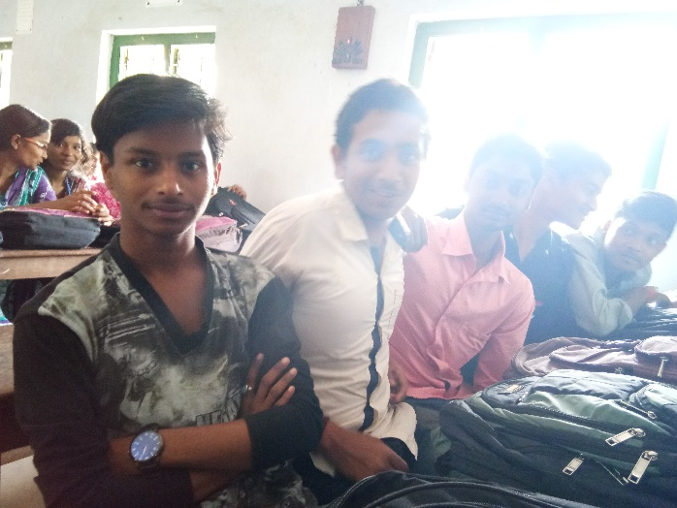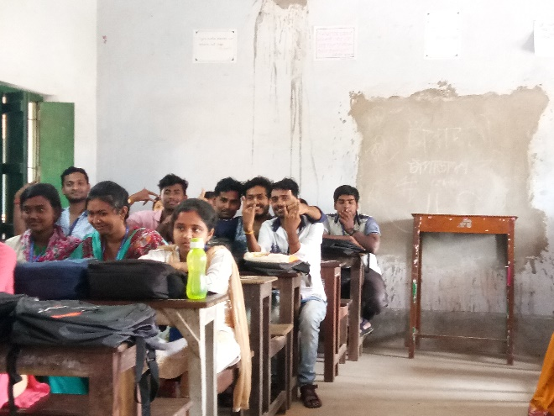
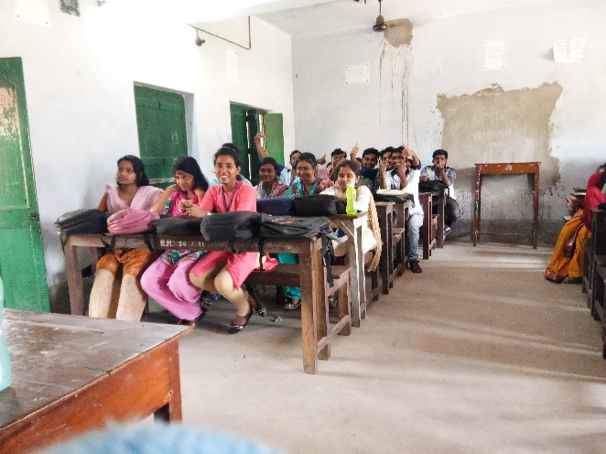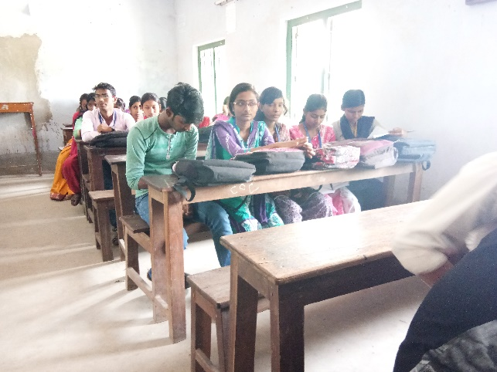
Our students

Attendance
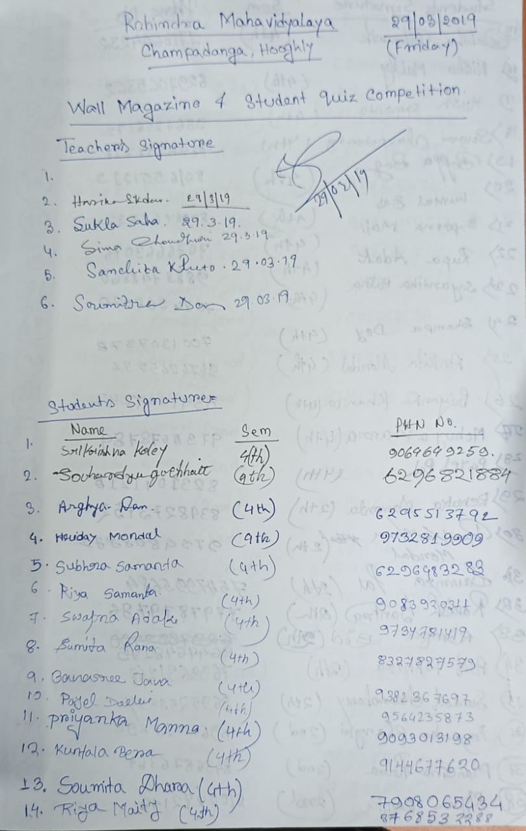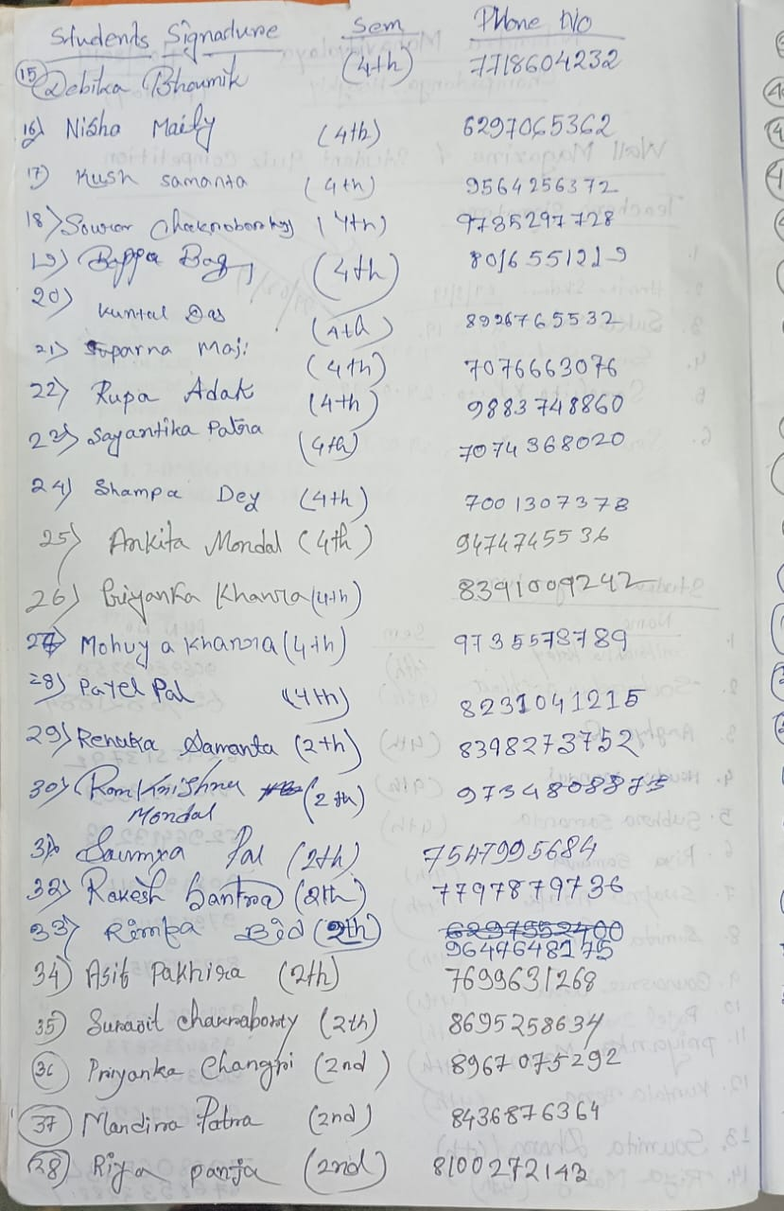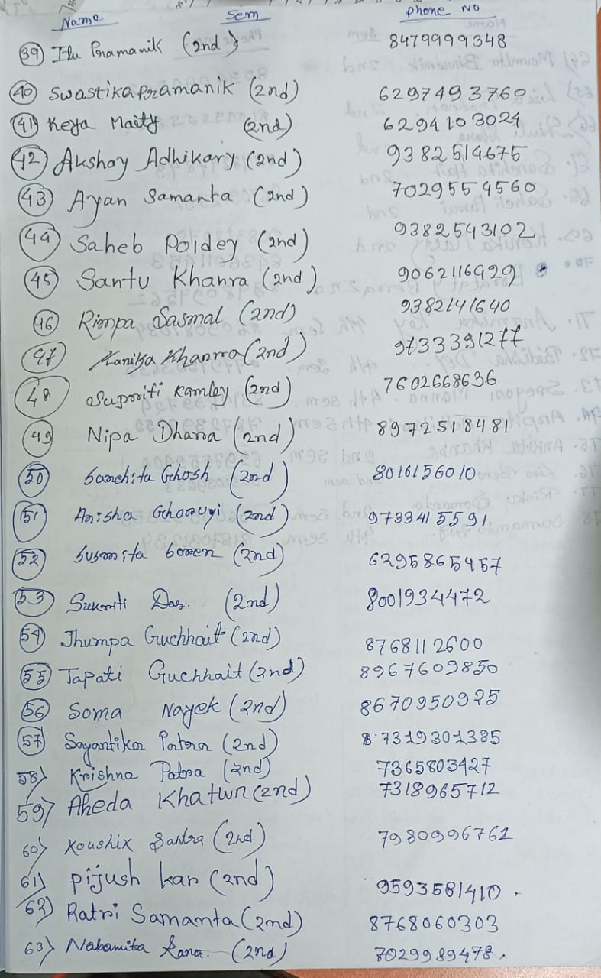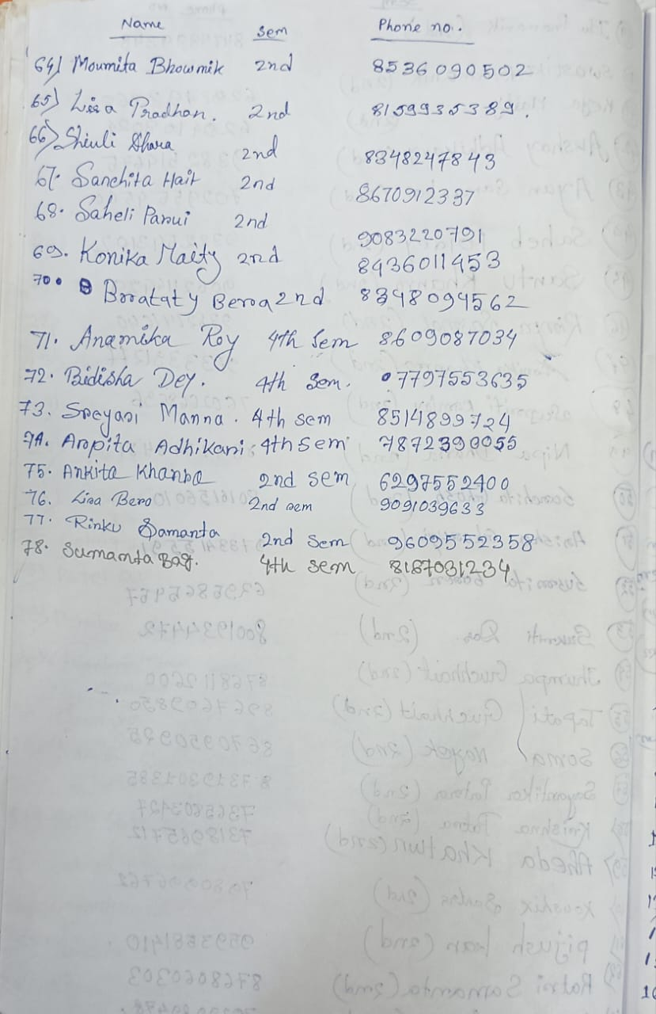
Our perticipent: 78
Male:20
Female:58

Tentative programme schedule:
- Inaugural session: 12 noon to 12.15 p.m.
- Theme present to audience: 12:15 p.m. to 12.30 p.m.
- Other speech:12.30p.m. to 1.00p.m.
- Lunch break: 1.00 p.m. to 1:30 p.m.
- Quiz competition: 1.30 p.m. to 2.30 p.m.
- Cultural programme: 1:30 p.m. to 4:30 p.m.

Feedback Summary
- 57 responses (73%) received.
- 78% felt satisfactory.
- 90% opined the event helped to improve their academic performance.
- 75% wished to occur the events more than once every year.

What have students learnt from the event?

- Presentation skills;
- Self-confidence;
- Critical thinking;

Suggestions for quiz
- More extra-curricular activities and healthy competition;
- Special class for grooming;

